

Project title
Gym Fitness and Workout Progress Tracking Portal
Student 1  Registration No. | Muhammad Hamza khan  2502941
Student 2  Registration No. | Awais Bajwa  2502857
Class | BSSE-II-A
Supervisor | Sir Zulfiqar Ali
Version | 1.0
Degree | Bachelor of science in Software Engineering

Chapter 1: Proposal

Introduction
The gym fitness and workout progress tracking application is designed to help users maintain a structured and healthy fitness routine. Many individuals struggle with improper workout techniques, a lack of progress tracking and poor communication with trainers. this system provides features such as workout plan management, bmi and calorie tracking, tutorial videos, and trainer-client communication. the application allows users to monitor their fitness progress and receive professional guidance. the goal of this project is to improve workout efficiency, safety, and motivation.

Purpose
The purpose of this Software Requirements Specification (SRS) document is to define the requirements for the Gym Fitness and Tracker Portal. This document is intended for multiple stakeholders involved in this project.
For developers: This SRS serves as a guide for understanding features and functionalities that need to be implemented. It provides use cases and technical specifications for coding and system design.
For trainers and end users: It explains what the system offers and how they can use it to achieve fitness goals they intend to have. It also serves as a reference for documentation writers creating user manuals.

Scope
The Gym Fitness and Tracker Portal is a web-based application that helps users manage their fitness routine. It solves these problems:
- Clients cannot easily communicate with trainers for guidance
- People fail to calculate calorie intake and protein requirements
- Exercising alone without progress tracking leads to loss of motivation
- Users only track weight, ignoring body fat and muscle mass
- Without proper demonstration, users perform workouts incorrectly
- Most people lack defined fitness goals
- Users track BMI, weight, calories separately making analysis hard
- No feedback on performance improvement
Proposed Solution:
- Direct communication between client and trainer
- Diet and nutrition tracking with automatic calorie calculation
- Visual progress tracking with graphs and reports
- Monitor multiple health indicators (BMI, body fat, weight)
- Set specific fitness goals (weight loss, muscle gain)
- All data stored in one centralized system
- Trainers can monitor client progress

Chapter 2 : SRS (Software Requirements Specification)

Functional Requirements
- Module 1: User Management
ID | Use Case
UM-UC1 | Register New Account
UM-UC2 | Log in to System
UM-UC3 | Update Profile
UM-UC4 | Logout
- Module 2: Workout Management
ID | Use Case
WM-UC1 | Create Workout Plan
WM-UC2 | Assign Plan to Client
WM-UC3 | View Assigned Plan
WM-UC4 | Track Workout History
WM-UC5 | Update Workout Plan
WM-UC6 | Delete Workout Plan
- Module 3: Progress Tracking
ID | Use Case
PT-UC1 | Log Body Measurements
PT-UC2 | Calculate BMI
PT-UC3 | View Weight Chart
PT-UC4 | View BMI History
PT-UC5 | View Performance Graph
- Module 4: Nutrition Tracking
ID | Use Case
NT-UC1 | Log Daily Food Intake
NT-UC2 | Track Calories
NT-UC3 | Track Protein
NT-UC4 | Track Macronutrients
NT-UC5 | View Nutrition Summary
NT-UC6 | Get Diet Recommendations
Module 5: Communication
ID | Use Case
TC-UC1 | Send Message to Trainer
TC-UC2 | Send Message to Client
TC-UC3 | View Message History
TC-UC4 | Provide Feedback
TC-UC5 | Receive Guidance
TC-UC6 | Share Progress with Trainer

Non-Functional Requirements

5.1 Reliability

- 99% uptime during peak hours (6 AM - 10 PM)
- Daily backups, restorable within 2 hours
- Handles 500 concurrent users
- Validates all inputs to prevent data corruption

5.2 Usability
- New users can register within 3 minutes
- All functions accessible within 3 clicks
- Error messages in plain language
- Responsive on all devices
- Consistent color coding: green (completed), yellow (warning), red (error), blue (interactive)

5.3 Performance
- 95% of pages load within 3 seconds
- Database queries under 500 milliseconds
- Charts generated within 2 seconds
- Messages delivered within 2 seconds
- Search results within 1 second

5.4 Security
- Passwords hashed with encryption
- Password must be 8+ chars with uppercase, lowercase, number, special characters
- Session timeout after 30 minutes
- Role-based access control
HTTPS with TLS 1.2+
- Protection against SQL injection, XSS, CSRF
- 5 failed login attempts = 30-minute lock

Chapter 3 : SRS (Software Design Specification)

Architectural design
The system follows a layered architectural consisting of three layers :
- Presentation layer(UI)
- Business logic layer (backend logic behind system)
- Data layer

Presentation layer

It handles all graphical user interface that interacts with user directly

- Business layer
It handles and processes coming request such as BMI calculation and workout assignment
- Data layer
It manages SQL database to store all data

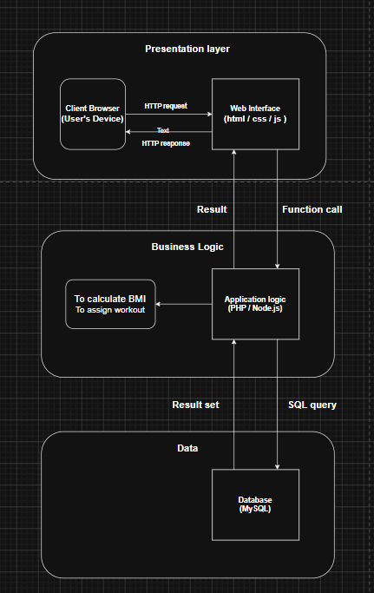
- The client browsers sends an HTTP request to Web interface that receives it
- The web interface passes the data via a function call ( like a function does math and returns an answer) to the application logic to process it (BMI calculator and workout assignment)
- The data is stored in MySQL database and returns all the way to the user’s device

Design models

Client user case diagram

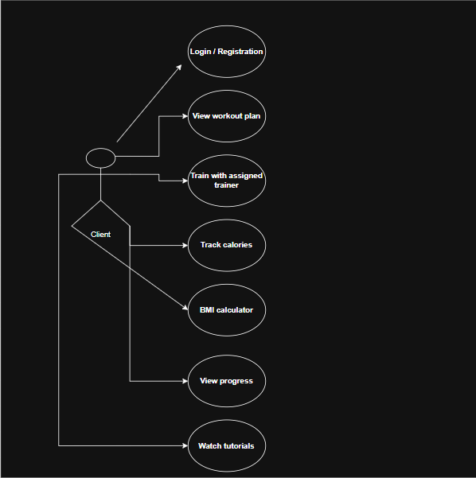

Trainer user case diagram

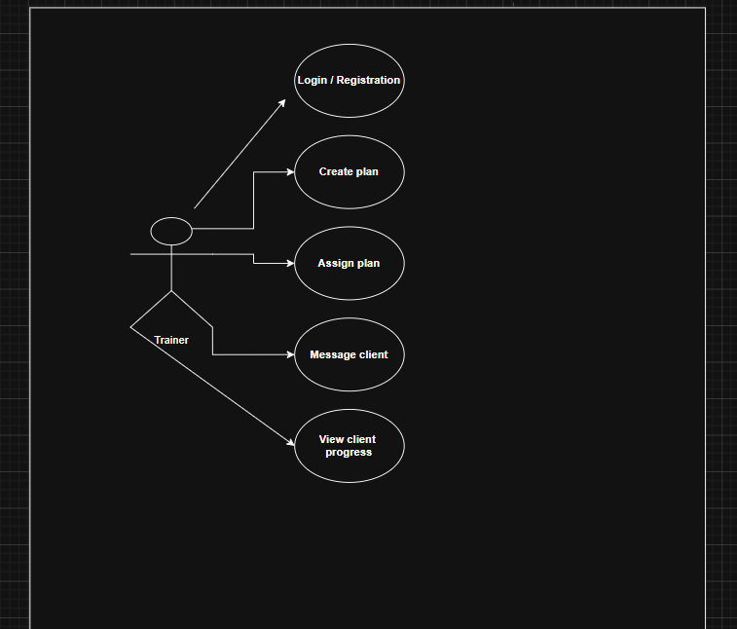

- Admin user case diagram

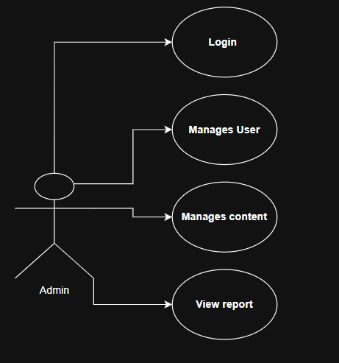

- Activity diagram
- Module 1 (Registration and login page)
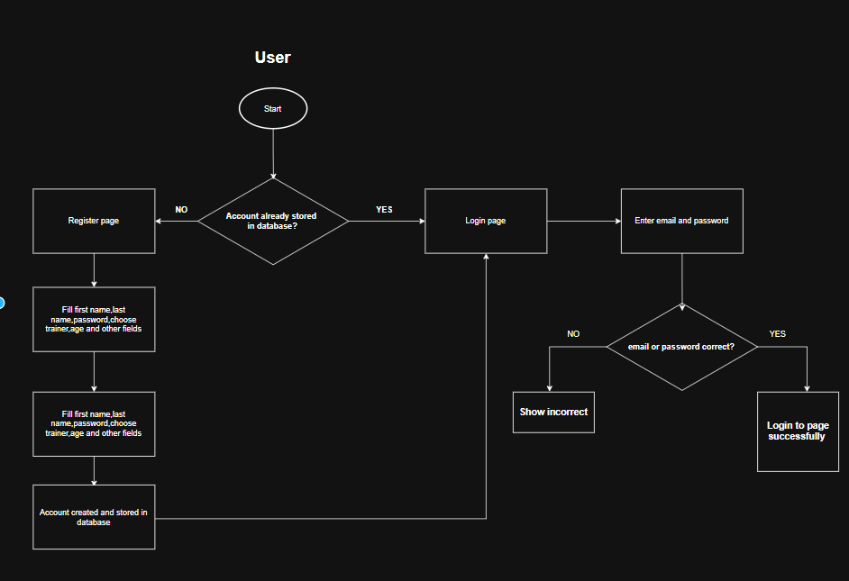

- Module 2 Create workout plan and mark exercise complete
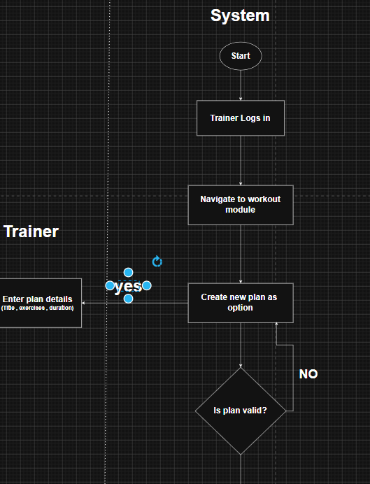
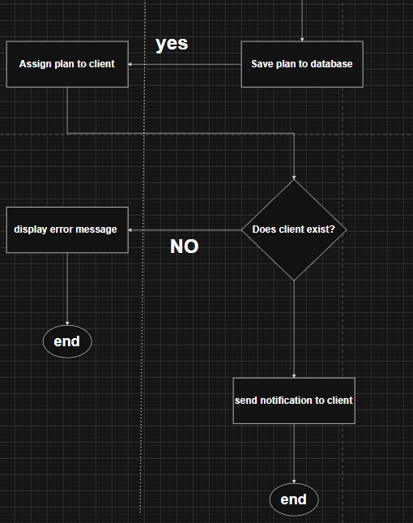

- Module 3 Create workout plan and mark exercise complete
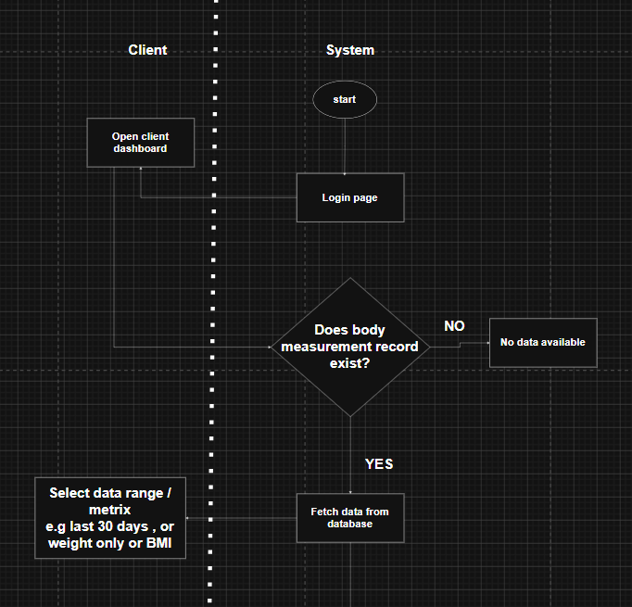
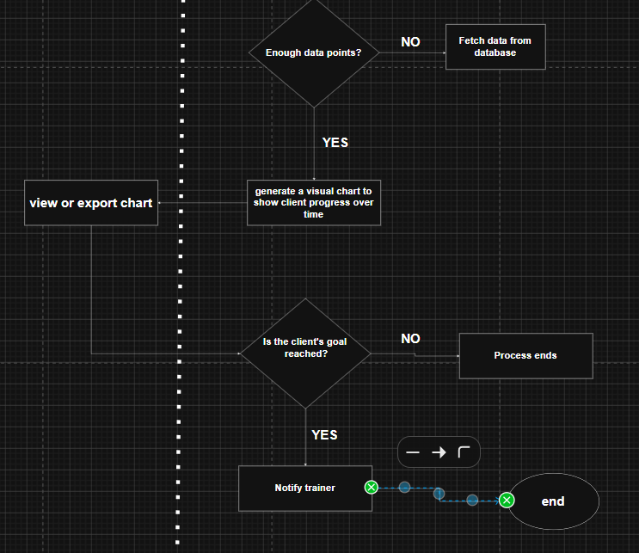

- Module 4 ( send message to trainer)
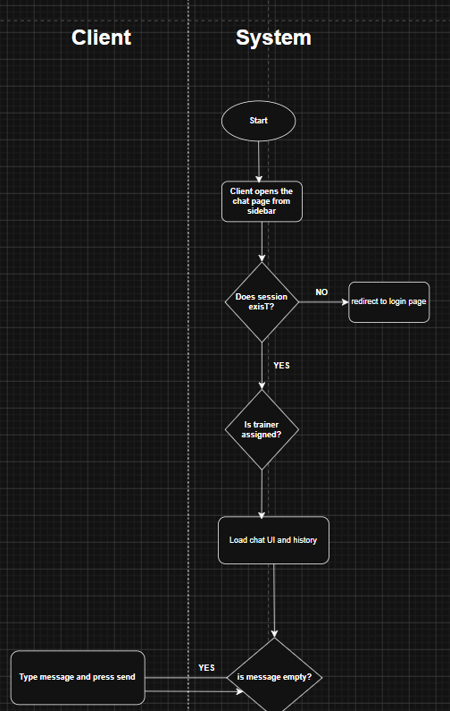
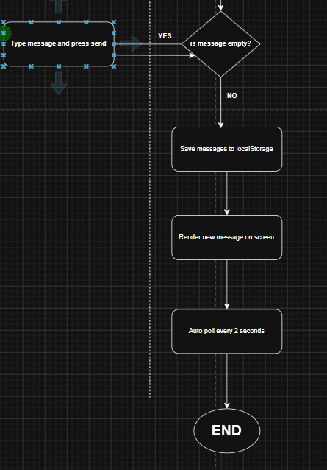

- Module 4 ( receive feedback from trainer )

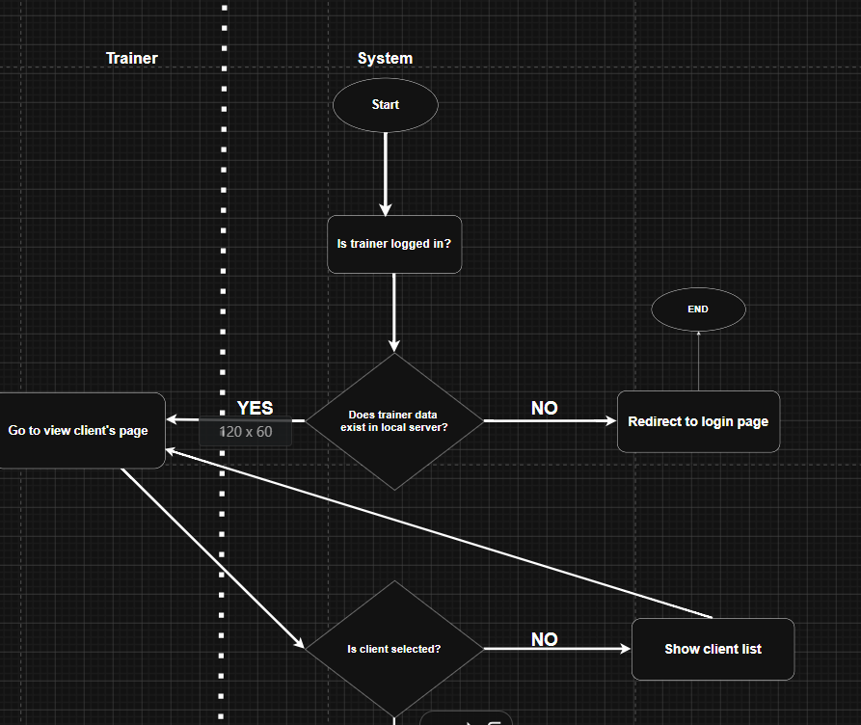
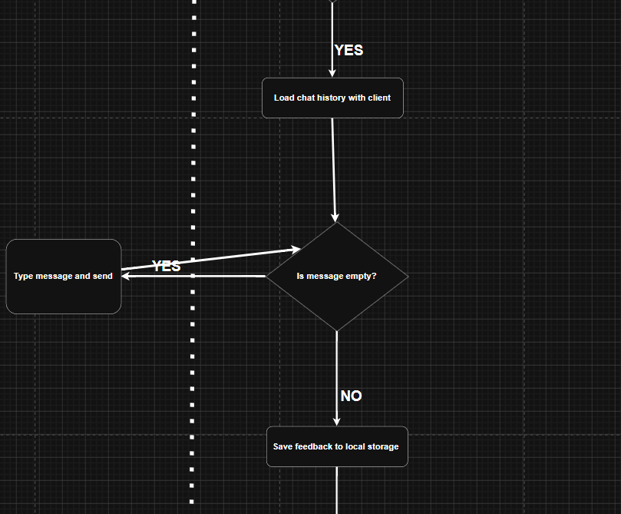
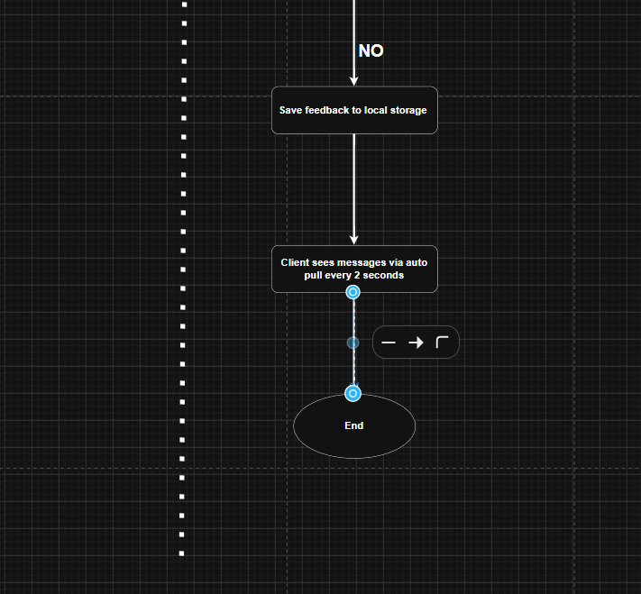

- Module 5 ( Log food daily intake and calorie tracker)
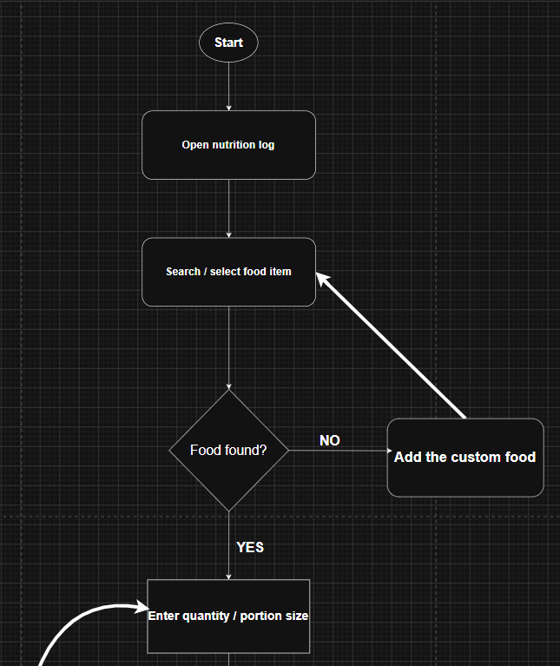
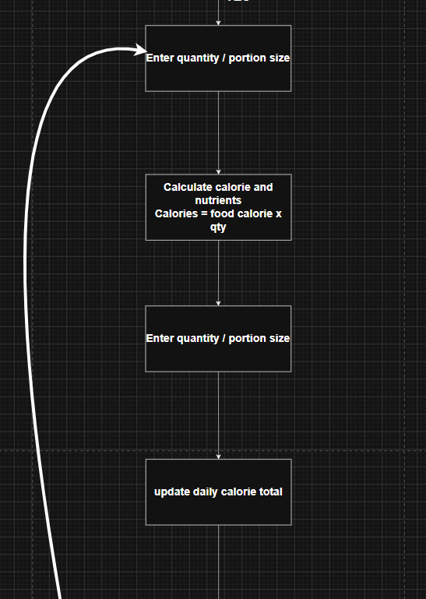
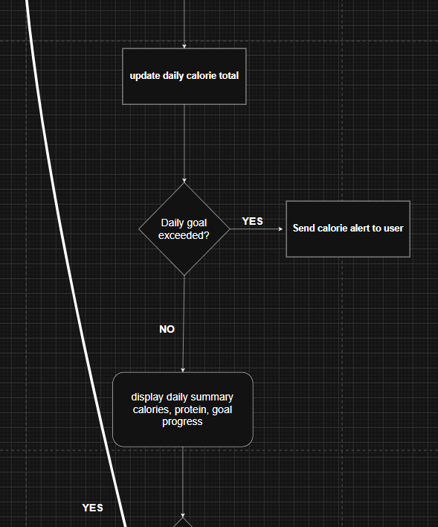
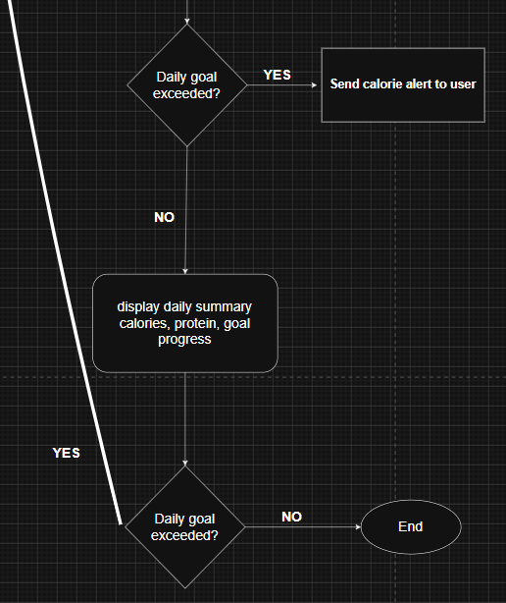

- Browse exercise tutorial module 6
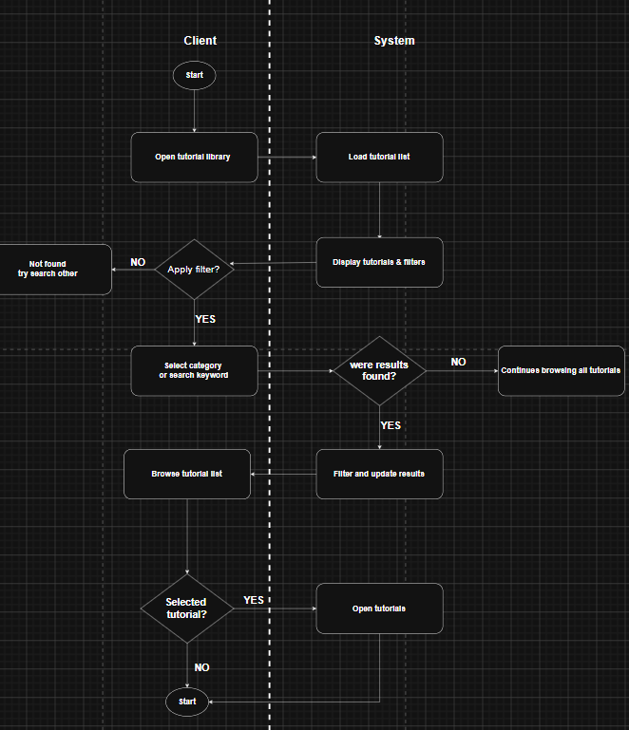

- Module 6 view tutorial video
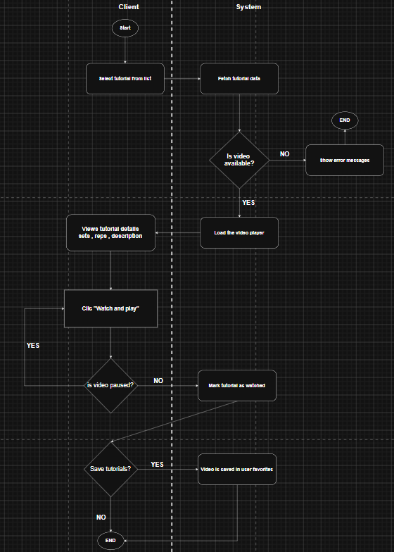

Class diagram-1 overall system

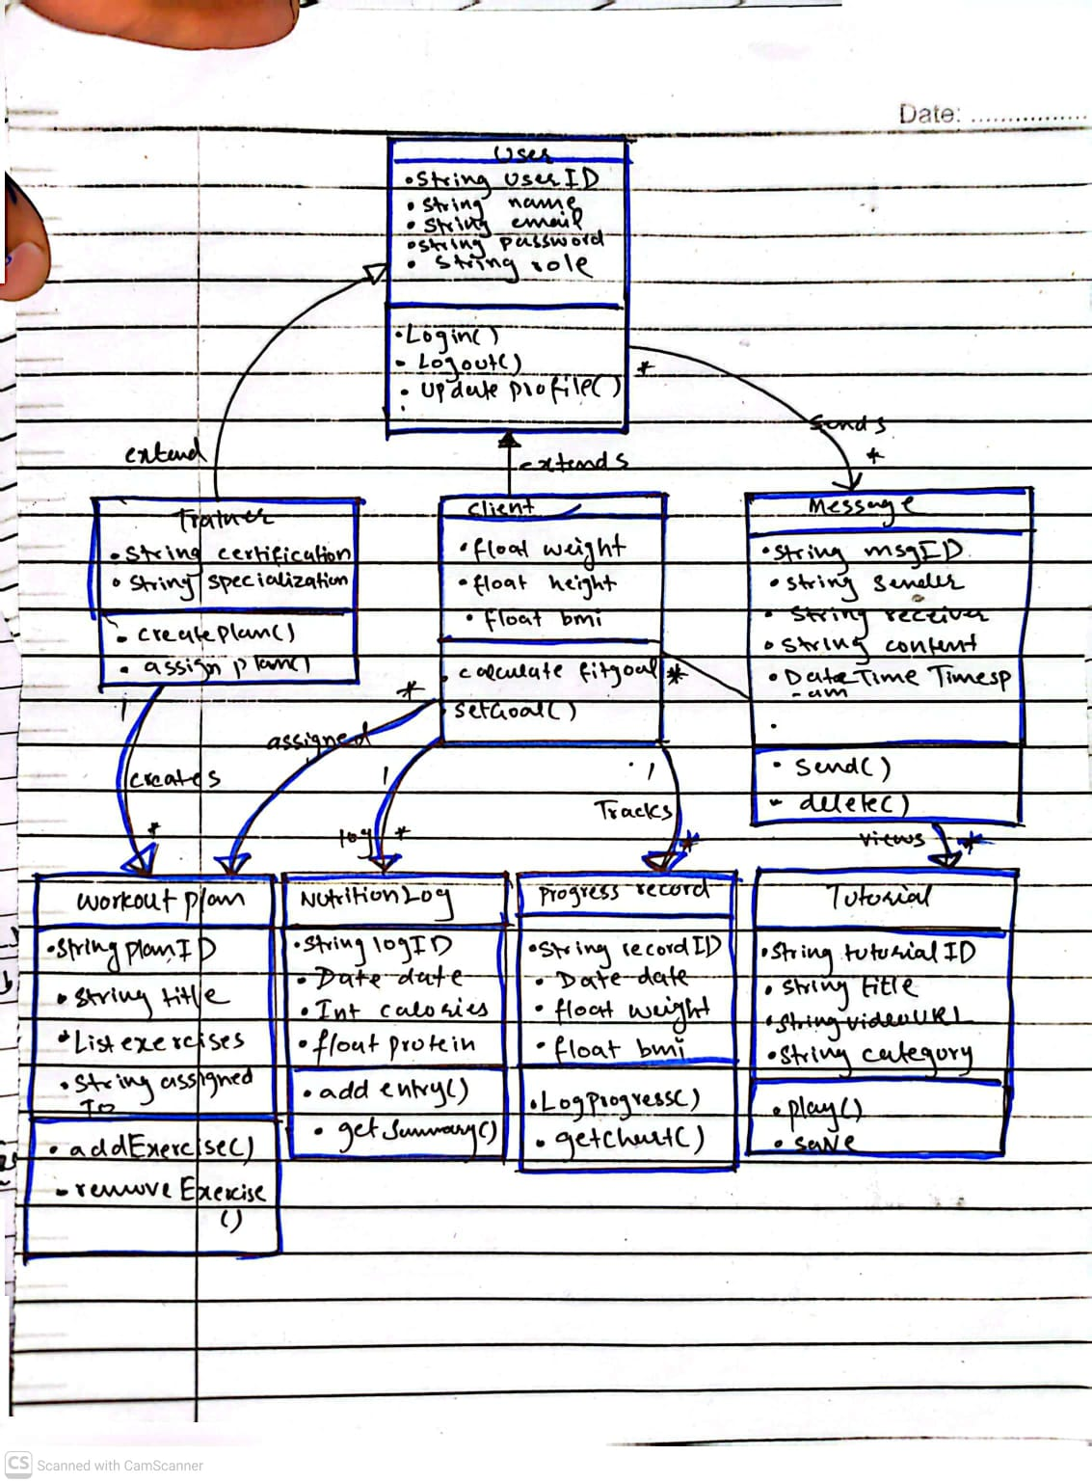

Sequence diagram

Registration page
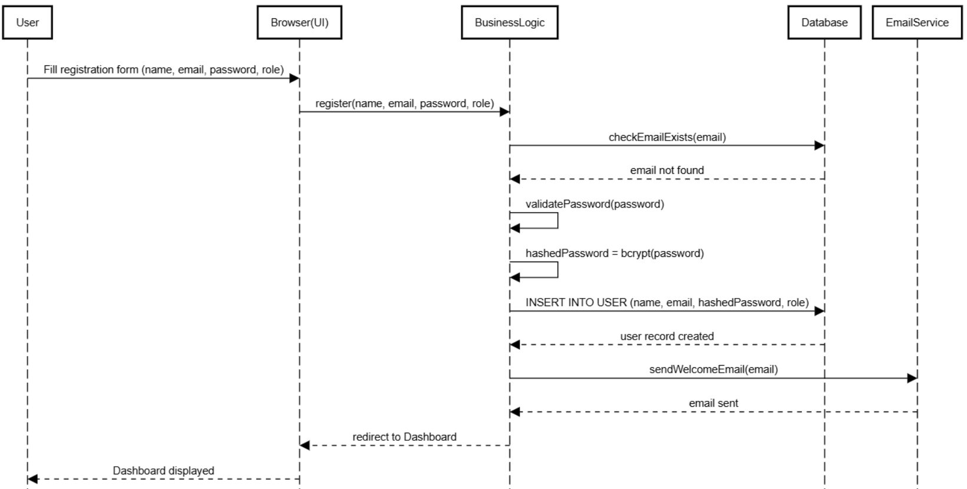
- User Logout
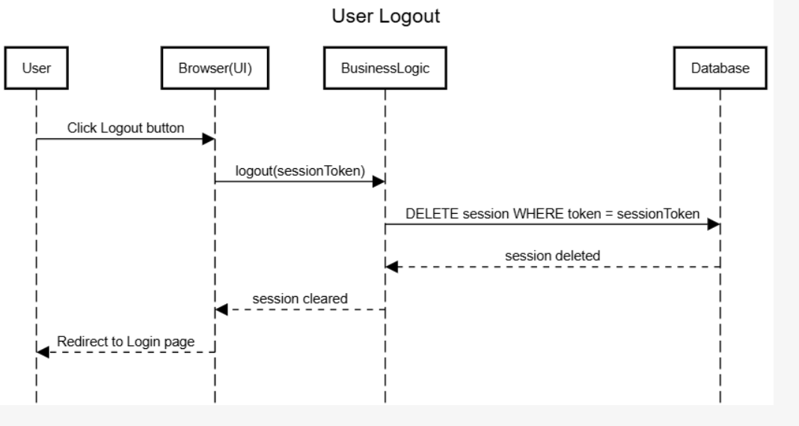

- Calculate BMI
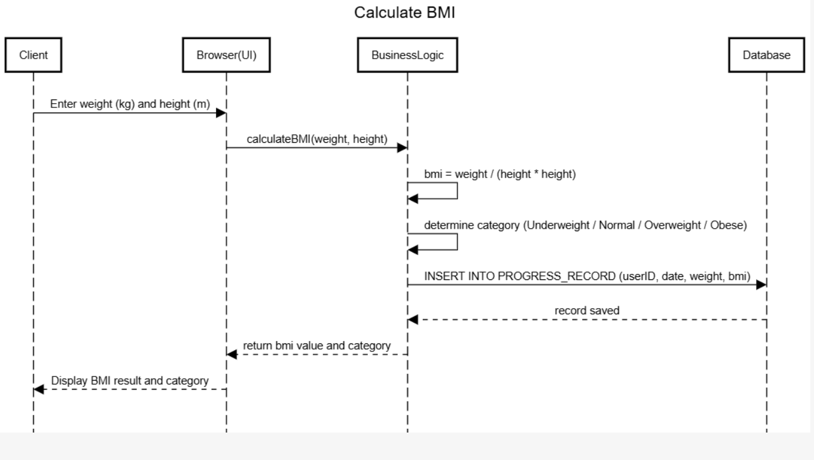

- Log body measurement and view progress
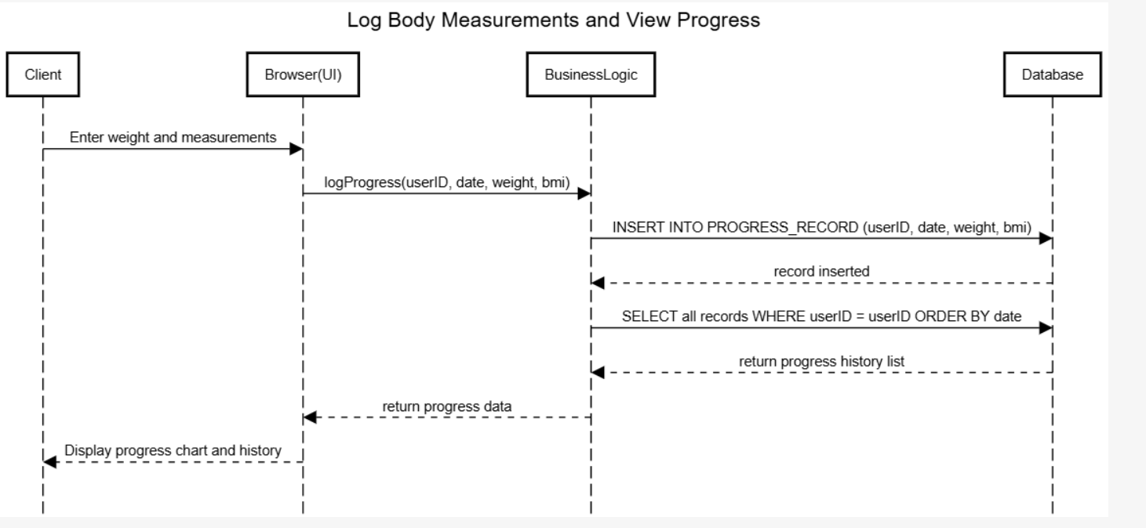

- Create workout Plan
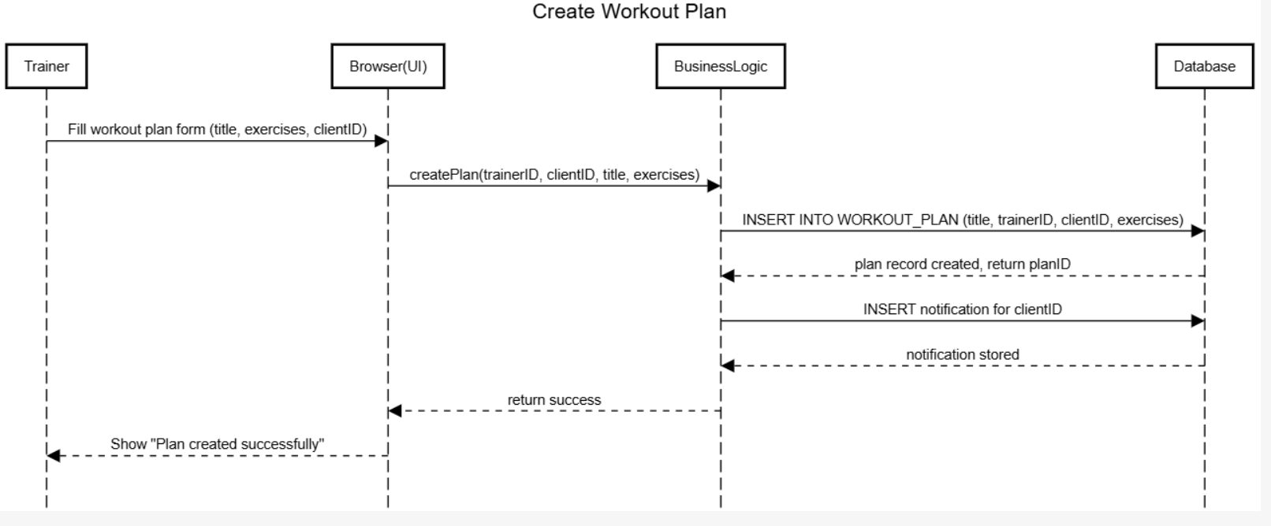

- Assign workout plan
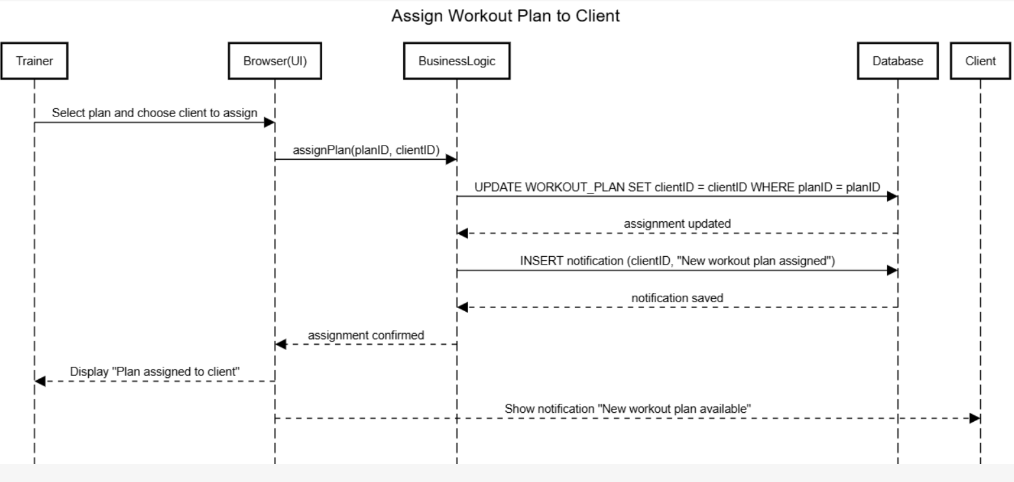

- Mark exercise as complete
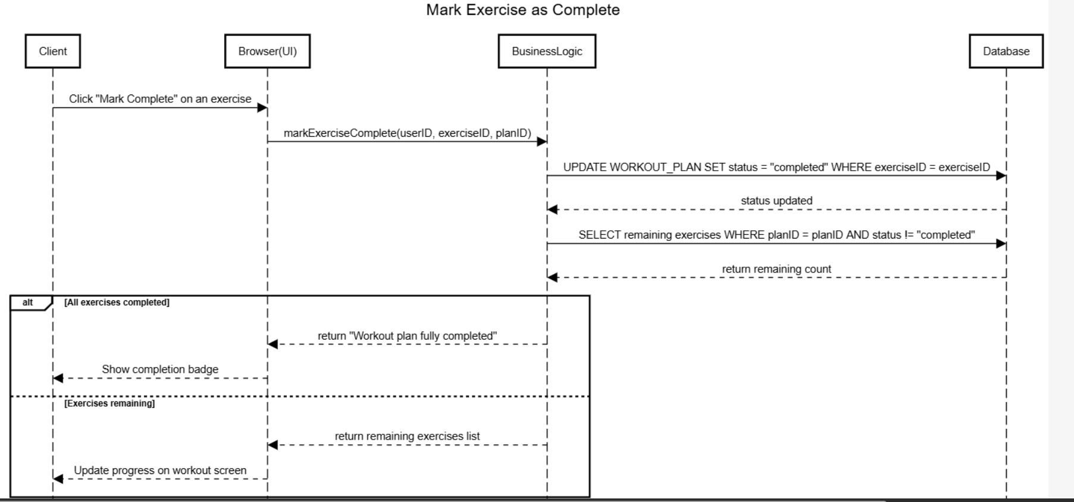

- Log daily calorie intake
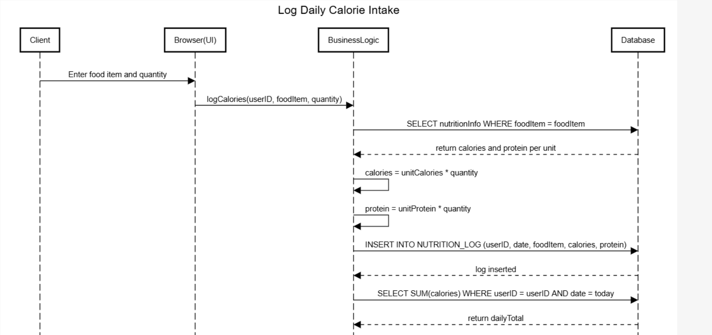
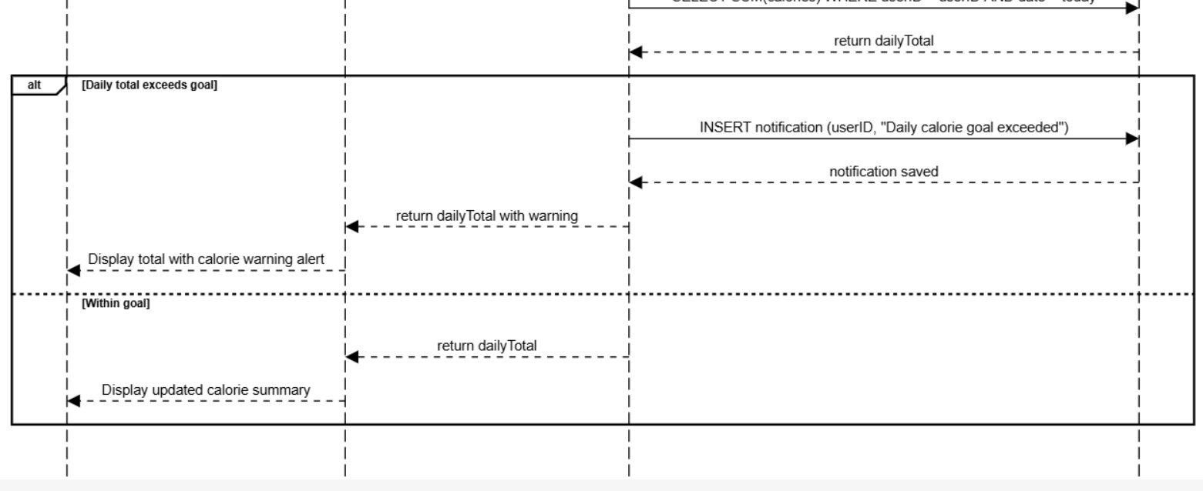

- Send message from client to trainer
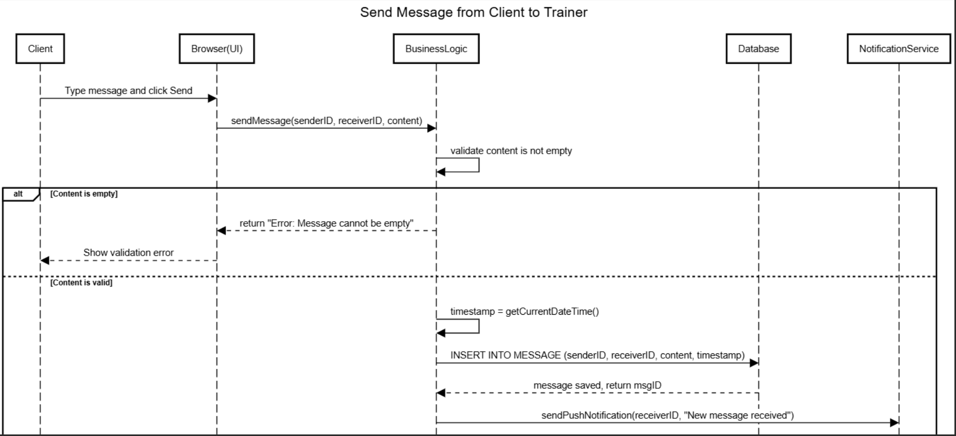
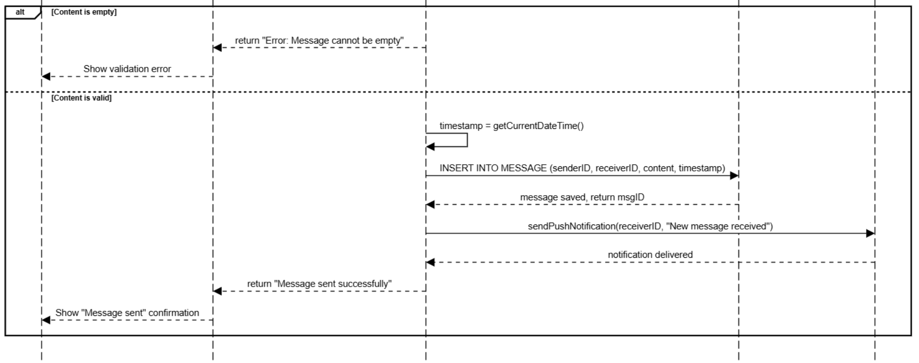
- Trainer provides feedback to client
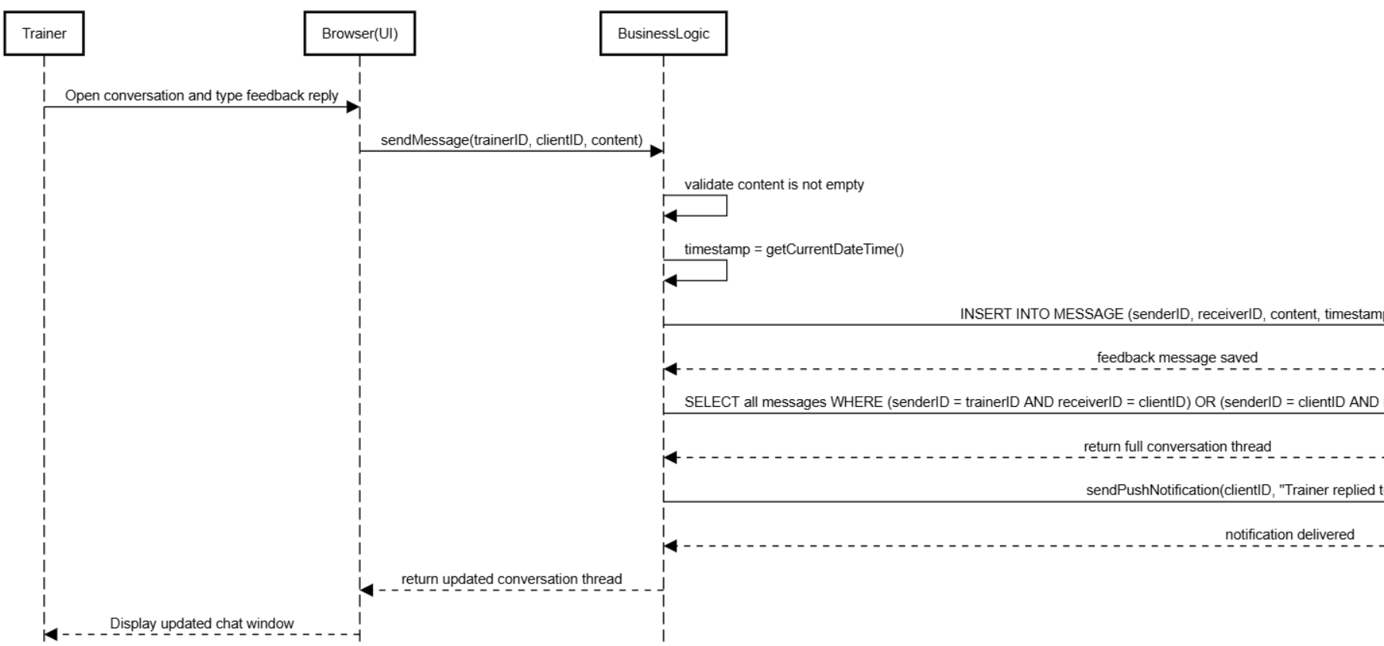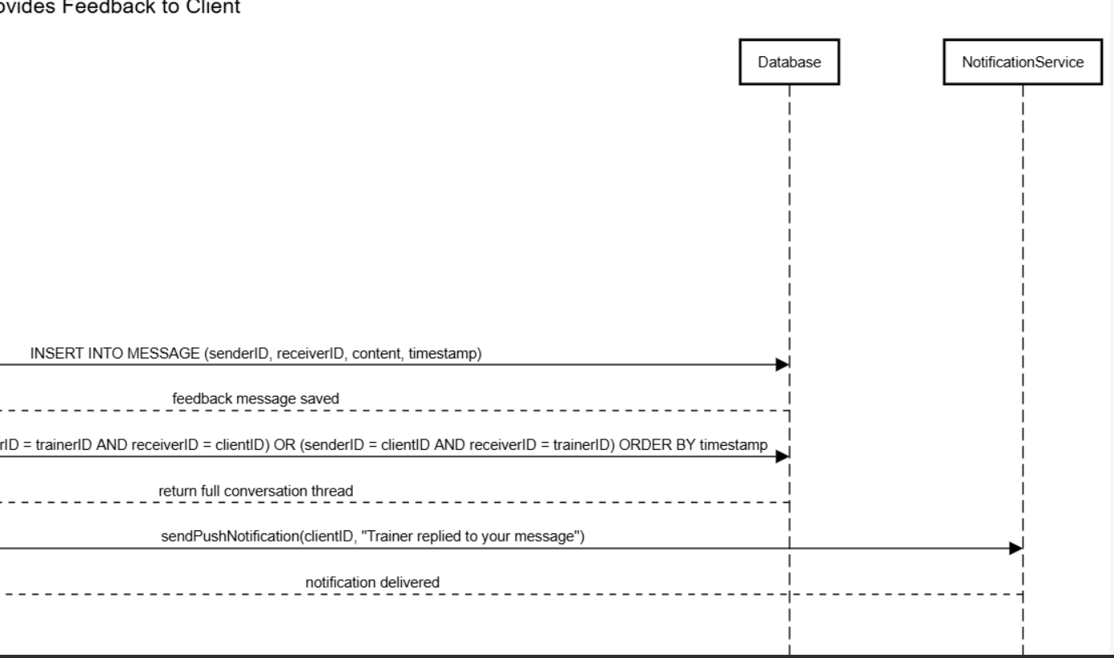

- Trainer provides feedback back to client
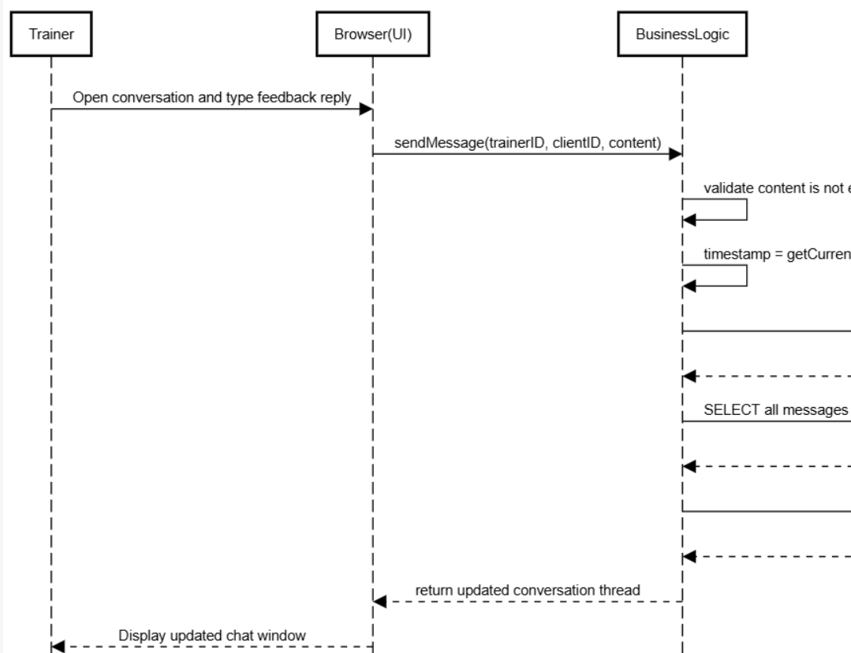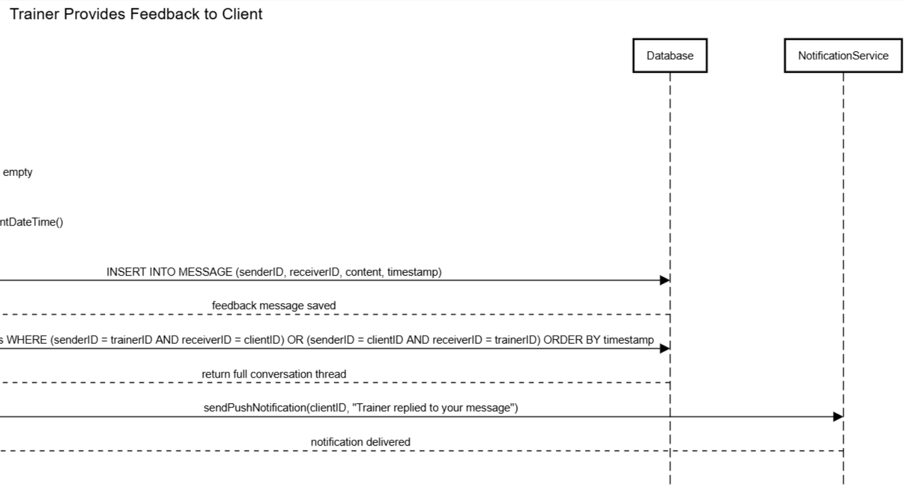

- Browse and watch exercise tutorial
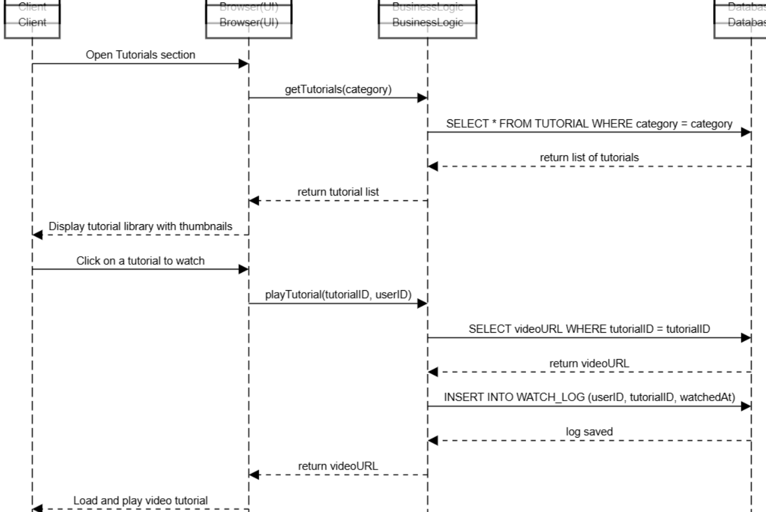

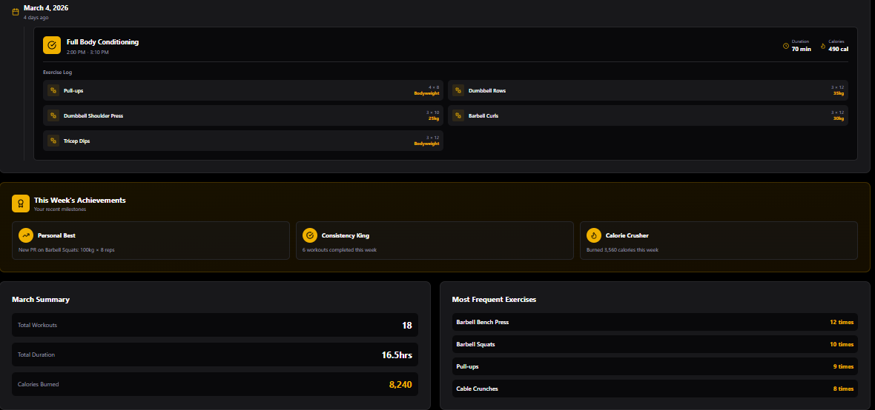

Data design
The system uses SQL relational database to store and manage all data. The major entities include User, Workout_plan , Nutrition Log , ProgressRecord , Message, and tutorial. Data is organized using primary and foreign keys to maintain relationships between entities and ensure data integrity.
- ER Diagram
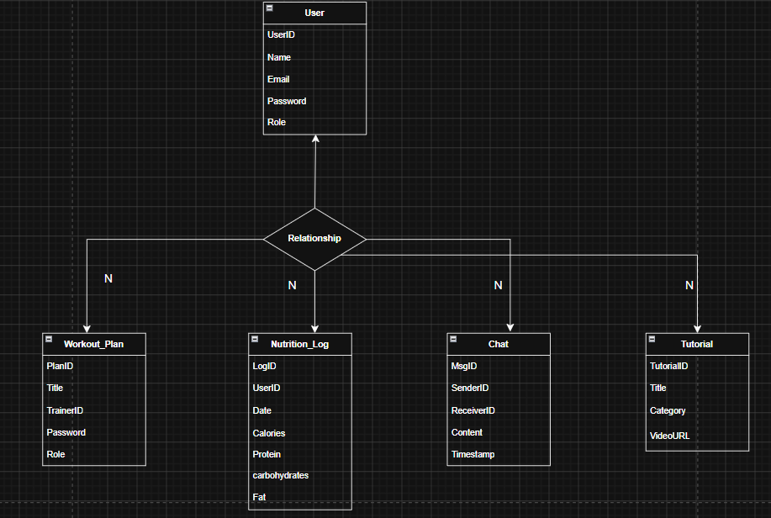

- Data dictionary table
Entity | Attribute | Data type | Description
chat | MsgID | int | Unique message identifier
chat | SenderiID | int | References UserID of sender
chat | ReceiverID | int | References UserID of receiver
chat | content | text | Text body of message
chat | Timestamp | DATETIME | Date and time message sent
NutritionLog | LogID | int | Unique log entry identifier
NutritionLog | UserID | int | Reference UserID of member
NutritionLog | Date | Date | Dte of nutrition entry
NutritionLog | calories | Decimal(6,2) | Total calorie intake for the day
NutritionLog | protein | Decimal(5,2) | Total protein intake
ProgressRecord | UserID | int | Reference UserID of member
ProgressRecord | Date | Date | Date the measurement was recorded
ProgressRecord | BMI | Decimal(4,2) | Calculated body mass index
Tutorial | Title | VACHAR(150) | Title/name of tutorial
Tutorial | TutorialID | int | Unique tutorial identofier
Tutorial | videoURL | VACHAR(255) | URL path to tutorial video
User | UserID | int | Unique idenitifer for each user
User | name | Vachar(100) | Full name of user
User | Email | VACHAR(100) | User’s unique email address
User | password | Vachar(255) | Hashed password for login
User | Role | ENUM(‘client,Trainer,Admin) | Defines user type in system
Workout_plan | PlanID | int | Unique workout plan identifer
Workout_plan | Title | Vachar(150) | Name / title of workout plan
Workout_plan | TrainerID | int | References UserID of trainer
Workout_plan | ClientID | int | References USERID of client

BMI Calculator Module:

Algorithm
- Start.
- Input height in centimeters and weight in kilograms.
- Convert height to meters: height\ m = height / 100.
- Calculate $BMI = weight / (height\ m^2).
- Determine category based on scale:
  - BMI < 18.5: Underweight
  - 18.5 – 24.9: Normal
  - 25.0 – 29.9: Overweight
  - BMI 30: Obese
- Output BMI value and category.
- End

PDL:
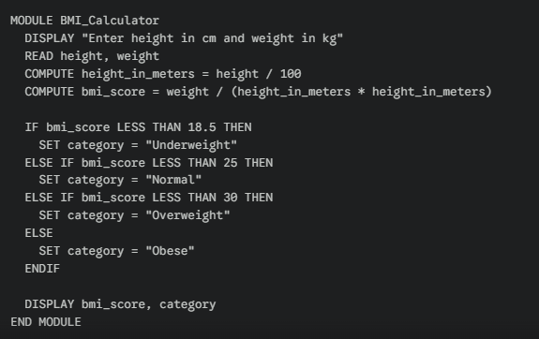

Pseudo Code:
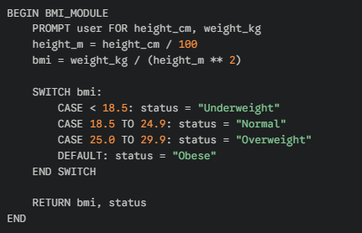

Nutrition Module:

Algorithm
- Start.
- Load Daily Goal (e.g., 2500 cal).
- Input Meal Data (Calories, Protein, Carbs, Fats).
- Update Total consume and specific macro totals.
- Calculate Remaining_Calories = Daily_Goal - Total_Consumed + Calories_Burned_from_Exercise.
- Calculate percentage completion for each macro.
- End.

PDL:
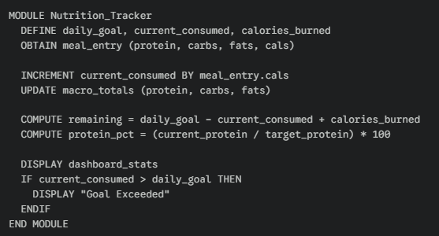

Pseudo Code:
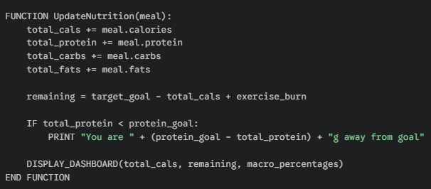

Workout Plan & History Module:

Algorithm
- Start.
- Load Weekly Schedule.
- If Day == today display Today's Workout (List of exercises, sets, reps).
- When exercise is completed, mark as Done.
- On workout completion, transfer data to Workout_History.
- Update Weekly_Progress metrics (Completion Rate, Volume).
- End.

PDL:
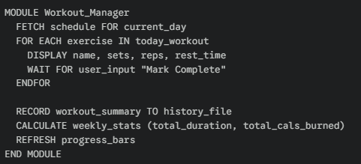

Pseudo Code:
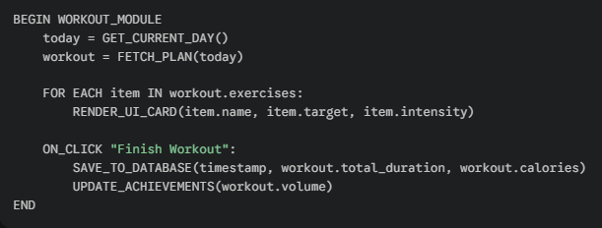

Trainer Chat Module:

Algorithm
- Start.
- Establish connection to Trainer_Server.
- Display message history.
- Input User_Message.
- Append User_Message to UI and send to server.
- On Receive_Message, update UI with trainer response and timestamp.
- End.

Pseudo Code
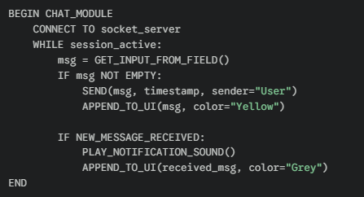

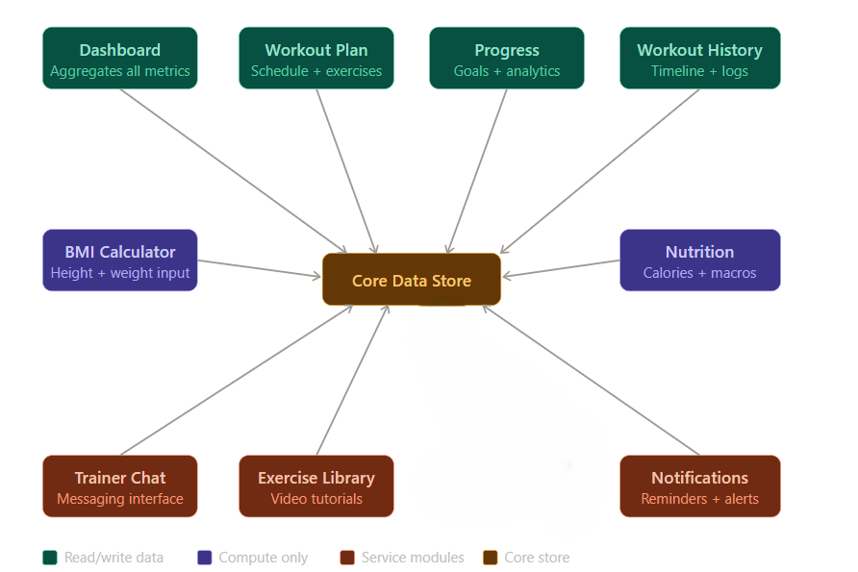

Chapter 4: Implementation

The Gym Fitness Tracker Portal System is developed using the following technologies:
- Frontend: HTML, CSS, JavaScript
- Backend Logic: JavaScript
- Database: MySQL lite
- Charts Library: Chart.js
- Development Tool: Visual Studio Code and antigravity

System working
The system starts with user authentication where users can register and log in.

Dashboard
After login:
- If the user is a client, they are redirected to the dashboard.
- The dashboard shows calories consumed or burnt, current weight, and workout Durant chart
-Users can also add workout logs to record their physical activities. The entered workout duration and calories burned are stored in the system, and the data is used to update the progress charts and records dynamically.

Nutrition module

Users can:
- Add food in the nutrition module
- Log workouts with duration and calories burned
- Update weight in progress module
The system stores all data in MySQL and updates dashboard values dynamically.

Progress Module
This module tracks weight changes, weekly calorie burn, and workout duration.
Graphs are updated dynamically based on user input.

Chat Module
This module allows communication between trainer and client.
Messages are stored and retrieved using MySQL

Trainer Dashboard
For trainers:
- Trainers can view assigned clients
- Trainers can send workout suggestions
- Trainers can chat with clients
All data is stored and retrieved in real-time within the browser.

Code Explanation

middleware/auth.js

JWT authentication middleware used to protect secure routes by verifying the Bearer token before granting access.

authController.js (Registration)
Handles user registration by validating input, checking for duplicate users, hashing passwords using bcrypt, and assigning a trainer to the client.

authController.js (Login)
Manages user login by verifying credentials using bcrypt and generating a JWT token valid for 7 days.

db.js (Database Schema)
Defines the database structure including all required tables and initializes a default trainer during first-time setup

db.js (Promise Wrapper)
Implements a promise-based wrapper to convert SQLite callback functions into async/await format, enabling better code handling.

workoutController.js
Handles workout-related requests with role-based logic, returning different data for trainers and client from the same endpoint.

. progress.js
Manages user progress tracking including weight logs and workout history through multiple user-specific endpoints.

Modules View:

Dashboard:
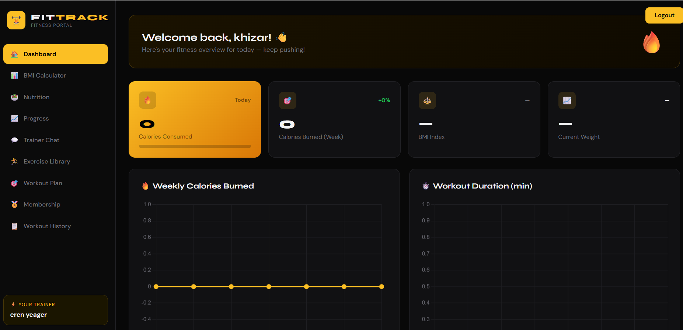

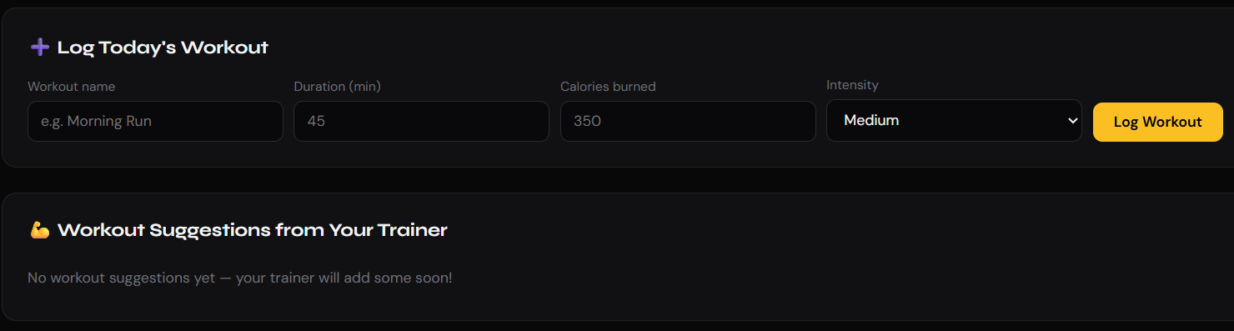

BMI Calculator:
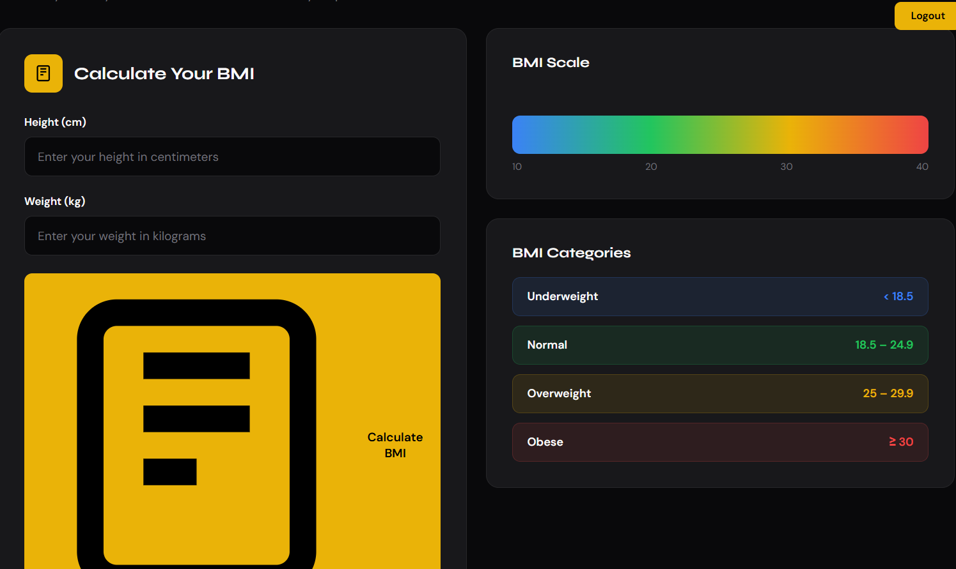

Workout Plan:
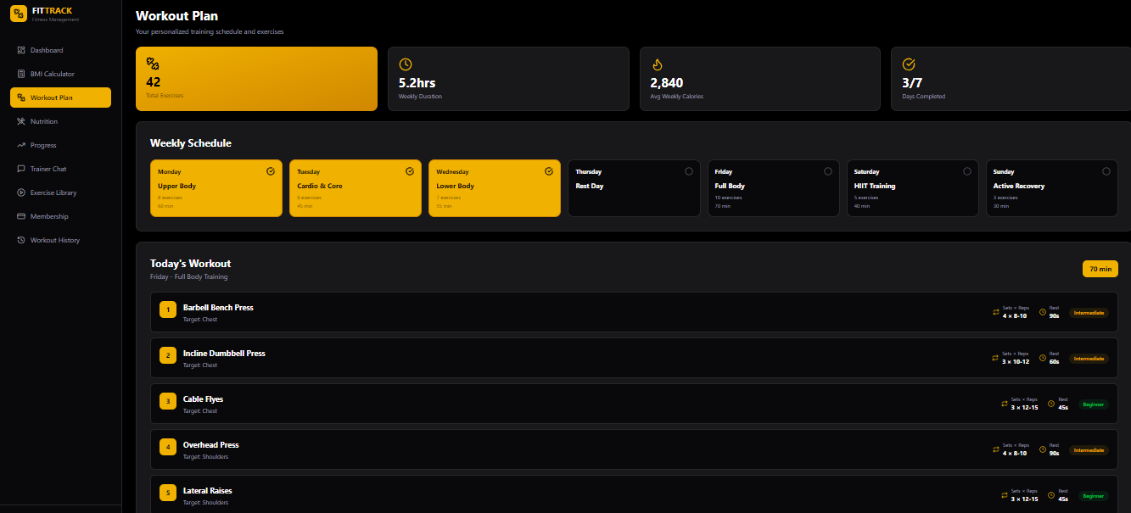

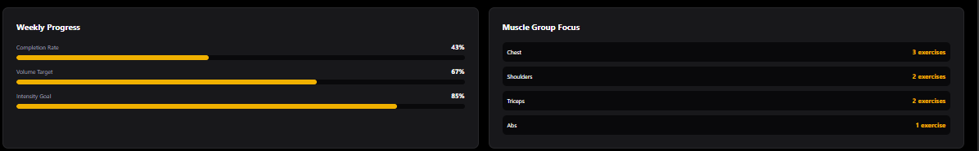

Nutrition:
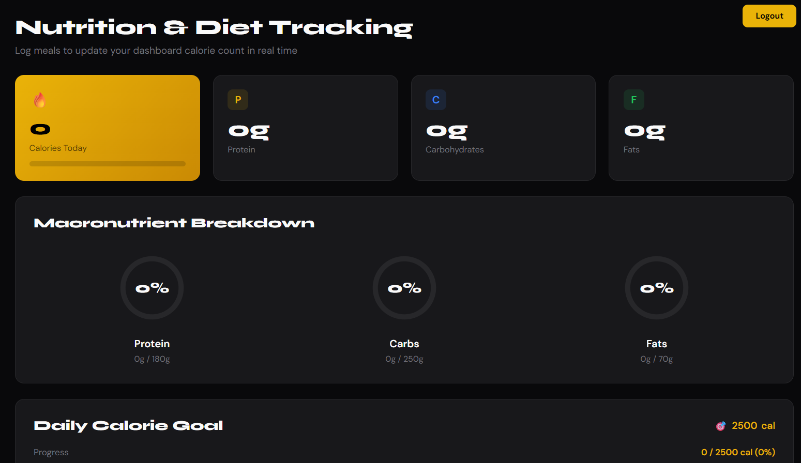

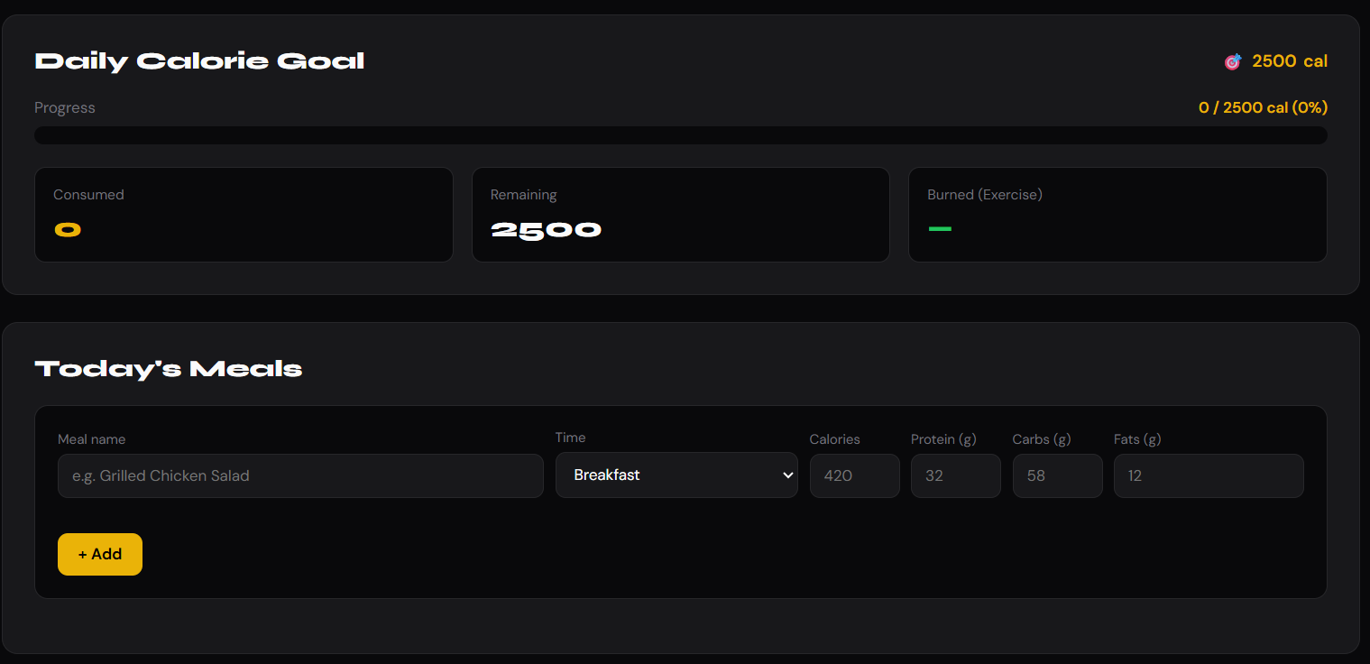

Progress:
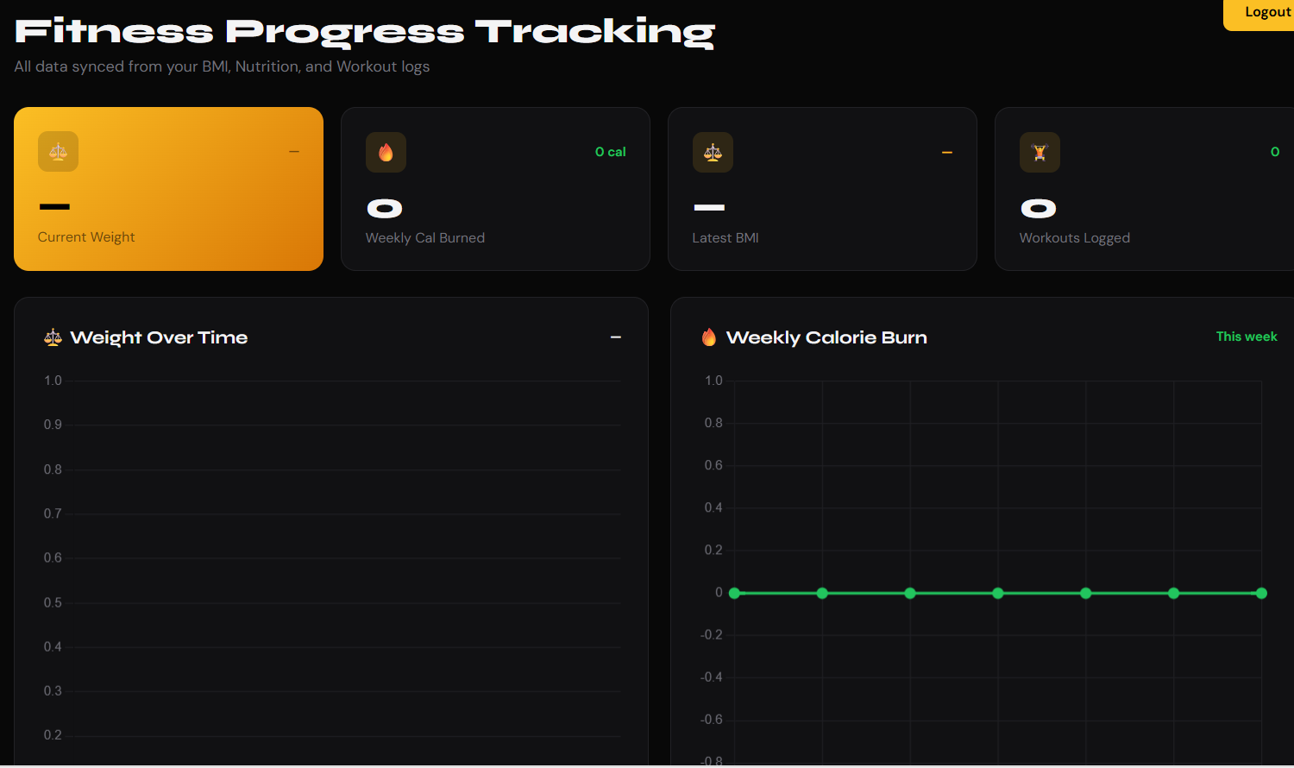

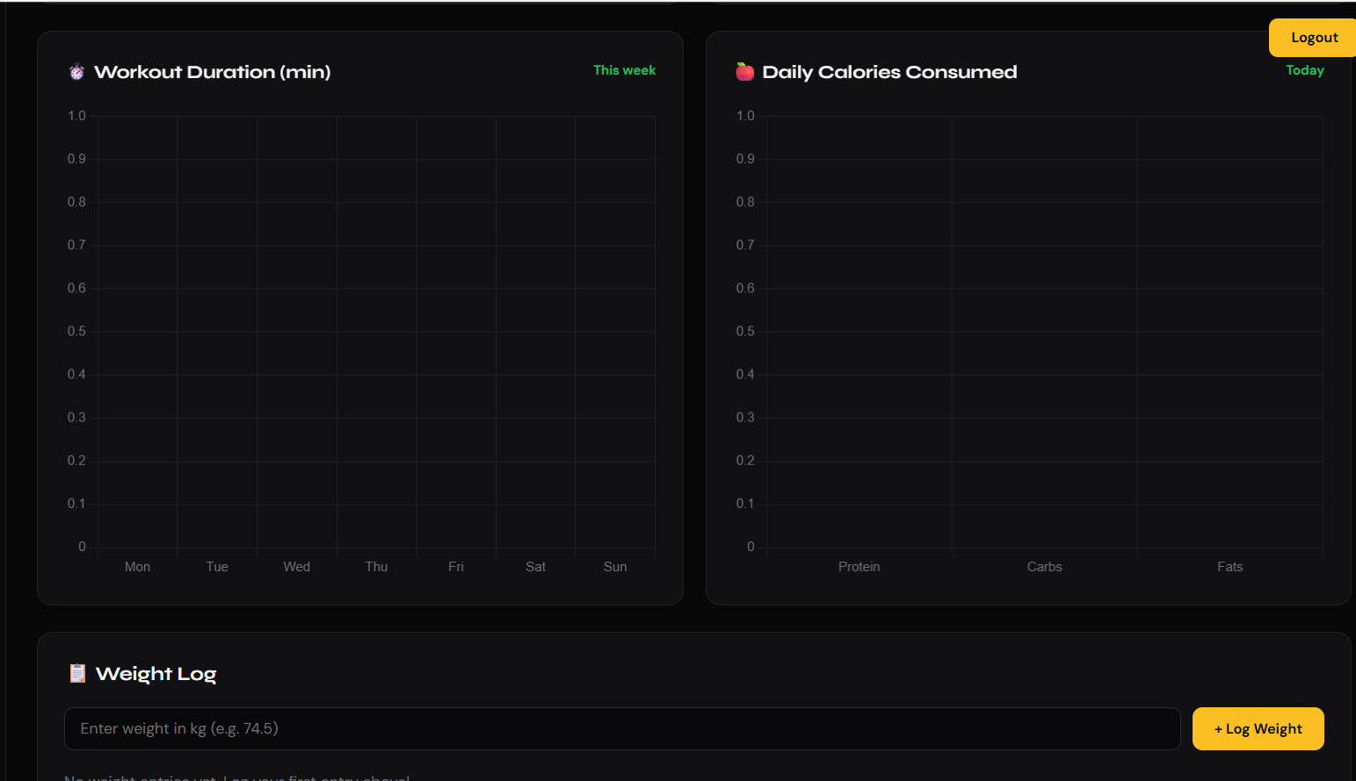

Trainer Chat:
